Psalm 150 Common Worship Chant: Sir Arthur Sullivan

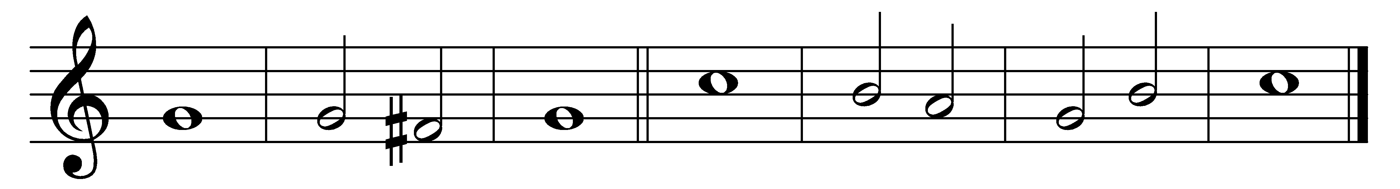

O praise | God in· his | holiness;

praise him in the | firma-· ment | of his | power.

2 Praise him for his | mighty | acts;

praise him ac-|cording· to his | excel-· lent | greatness.

3 Praise him with the | blast· of the | trumpet;

praise him up-|on the | harp and | lyre.

4 Praise him with | timbrel· and | dances;

praise him up-|on the | strings and | pipe.

5 Praise him with | ringing | cymbals;

praise him up-|on the | clashing | cymbals.

6 Let every-|thing· that has | breath

praise | - - | - the | Lord.

Words taken from Common Worship © The Archbishops’ Council 2000.